**Диагностика**

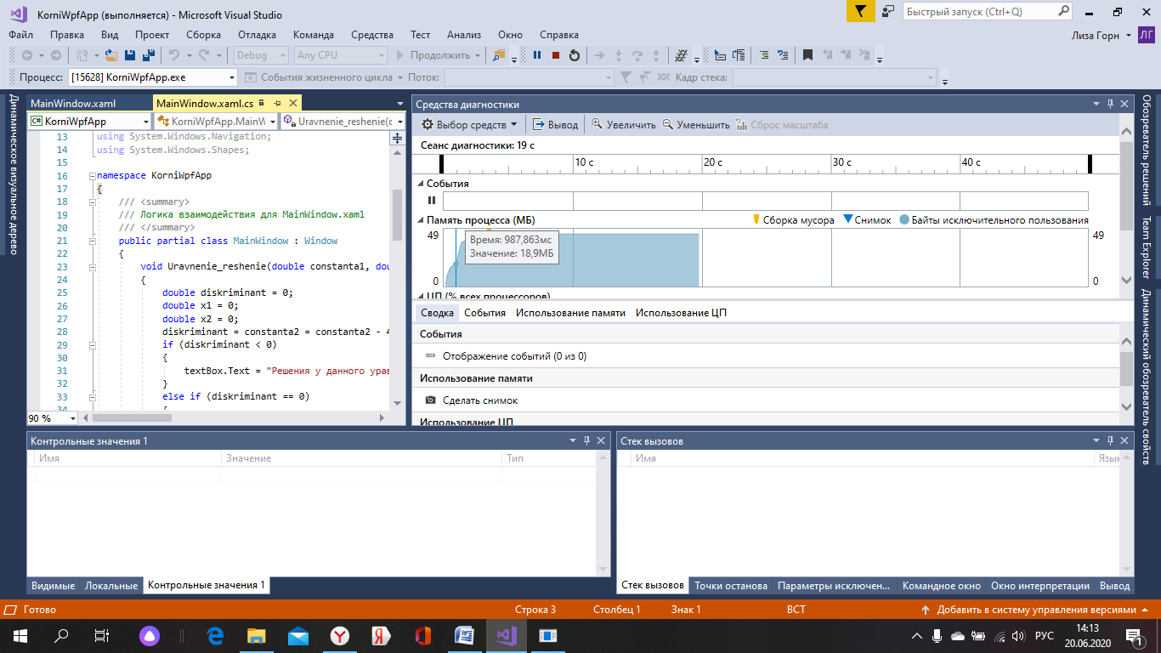

**Анализ**

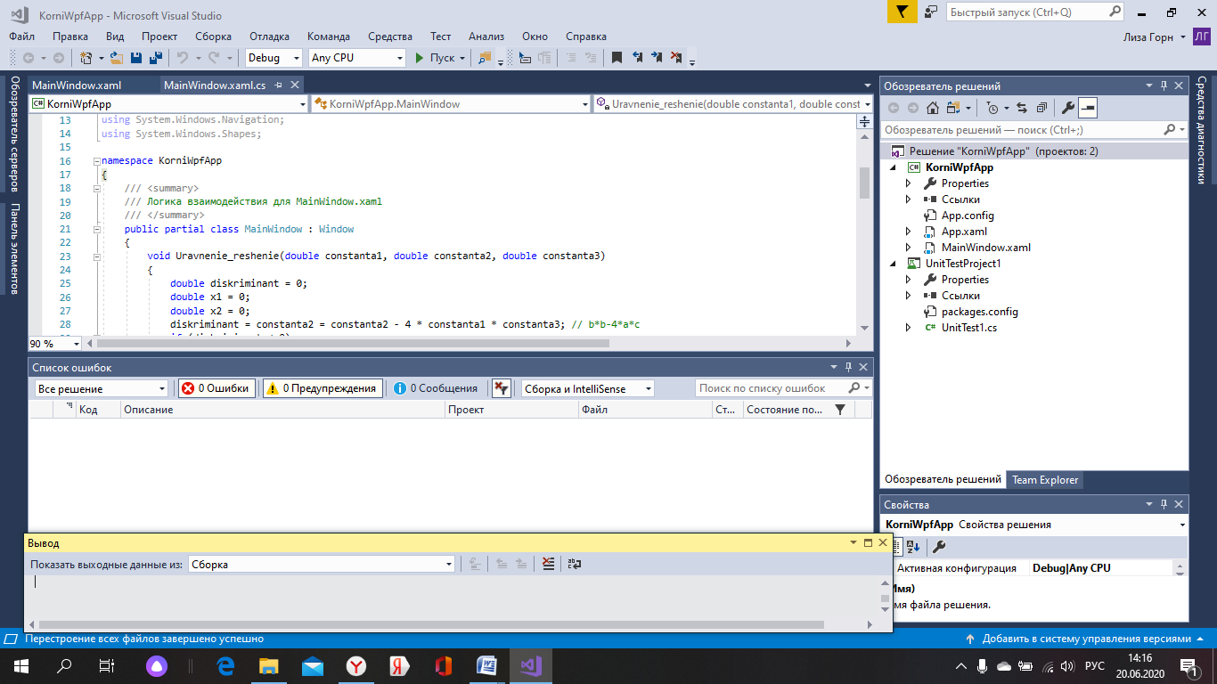

**Unit- тест**

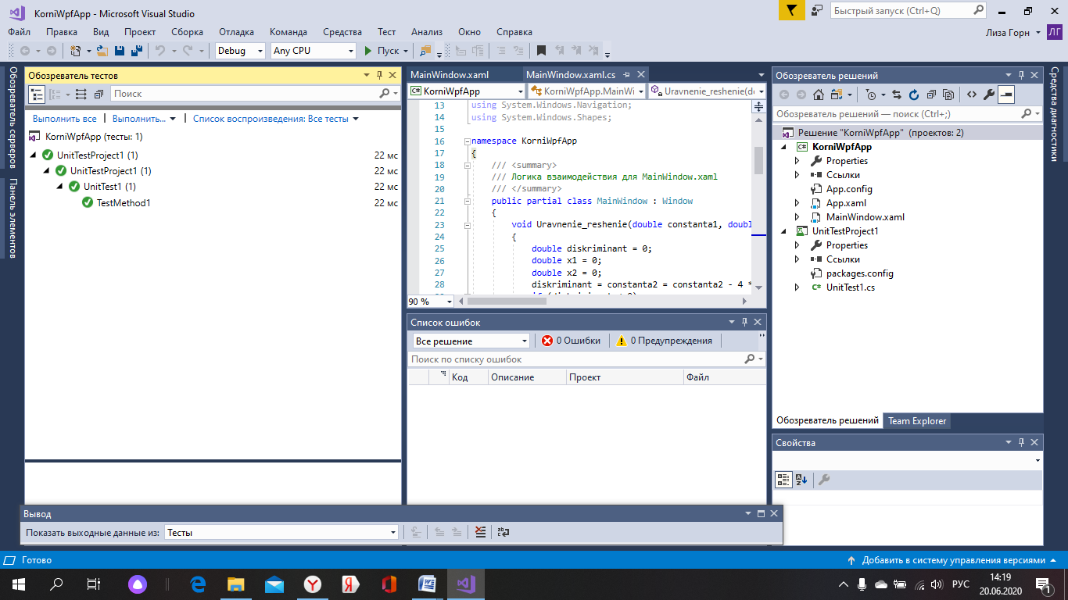

using System;

using Microsoft.VisualStudio.TestTools.UnitTesting;

using KorniWpfApp;

namespaceUnitTestProject1

{

[TestClass]

Public class UnitTest

{

[TestMethod]

Public void is TrueTest()

{

Assert.IsTrue(MainWindow.isTriagle(a,b,c));

}

}

}